Influential Factors Shaping Restaurant Ratings

2023

**Table of Contents**

**Executive Summary ---------------------------------------------------------2**

**1: Introduction ---------------------------------------------------------------2**

**2: Approach--------------------------------------------------------------------3**

**3: Insights from Exploratory Data Analysis (EDA) ------------------3**

**4: Model Development and Evaluation----------------------------------6**

**5: Solution Recommendation----------------------------------------------7**

**6: Technical Recommendations-------------------------------------------8**

**7: References------------------------------------------------------------------10**

**Executive Summary**

This executive summary encapsulates our comprehensive analysis and recommendations for enhancing restaurant ratings and customer preferences on the FoodieBay platform. Through rigorous data analysis, we unearthed key insights, including the impact of table booking and online ordering on ratings. Leveraging machine learning models, specifically the RandomForestRegressor and K-Nearest Neighbors Regressor, we identified powerful tools for optimizing restaurant ratings.

Our recommendations include promoting table booking services to boost customer satisfaction and encouraging restaurants to adopt online ordering for added convenience. The implementation of machine learning models promises more accurate and insightful ratings, underpinning FoodieBay's commitment to user experience. To sustain these improvements, a continuous feedback loop and ethical considerations must be integrated.

In conclusion, these measures are poised to elevate FoodieBay's platform, fostering user loyalty and cementing its position as a premier culinary destination. A strategic and phased approach to implementation ensures a seamless transition towards these enhancements.

**1. Introduction**

The aim of this endeavor is to address a significant business challenge within the broader context of the restaurant industry and articulate the value it brings. In today's dynamic restaurant landscape, achieving and sustaining high ratings while comprehending customer preferences is of utmost importance. FoodieBay, a prominent player in this sector, acknowledges the critical role that data-driven insights and machine learning can play in enhancing its platform. The central business challenge revolves around the imperative to improve restaurant ratings and customer contentment, ultimately enhancing the overall user experience.

In this framework, the value proposition of this project becomes clear. By harnessing the potential of data analysis and machine learning, FoodieBay can offer its users more precise and tailored restaurant ratings and recommendations. This not only ensures a more gratifying dining experience but also cements FoodieBay's status as a premier destination for culinary exploration. The project's triumph will result in heightened user involvement, heightened customer loyalty, and augmented competitiveness in the restaurant discovery and reservation sector. It represents a strategic step that aligns with FoodieBay's dedication to excellence and innovation in serving the evolving preferences of its user community.

**2. Approach**

Our strategy for tackling the challenge of improving restaurant ratings and catering to customer preferences on the FoodieBay platform involves a comprehensive machine learning approach. This approach encompasses various machine learning methodologies, including both supervised and regression techniques. Our central objective revolves around the prediction of restaurant ratings, a critical metric influencing user satisfaction and restaurant performance assessment.

In this venture, we tap into the vast repository of data available on FoodieBay, encompassing user reviews, restaurant attributes, and user profiles. We engineer a set of features that encapsulate sentiment analysis, user demographics, and restaurant characteristics to create a robust and informative dataset. Subsequently, we deploy a range of regression models, including but not limited to Linear Regression, Ridge, Lasso, ElasticNet, DecisionTreeRegressor, RandomForestRegressor, GradientBoostingRegressor, SVR, and KNeighborsRegressor, to construct predictive models.

The focal point of our predictions in this project is restaurant ratings, serving as a crucial indicator of user contentment. By accurately anticipating these ratings, we empower FoodieBay to deliver more precise recommendations to its users while providing restaurant owners with invaluable insights to enhance their offerings. This multifaceted machine learning approach is poised to optimize restaurant ratings and reshape the user experience on the FoodieBay platform.

**3. Data Preparation and Exploratory Data Analysis (EDA)**

In the data preparation phase of our project, we undertook the task of collecting data from diverse sources, encompassing user reviews, restaurant attributes, and user profiles. This dataset, characterized by its substantial volume and varying data types and origins, demanded meticulous attention to data quality. To ensure the reliability of our subsequent analysis, we meticulously cleaned and pre-processed the data, addressing missing values, outliers, and inconsistencies with diligence.

Following the rigorous data cleansing process, we transitioned to the Exploratory Data Analysis (EDA) phase, where we combined statistical analyses with data visualization techniques to unveil valuable trends and patterns hidden within the dataset. EDA brought to light several pivotal insights, including the distribution of restaurant ratings, the impact of services such as table booking and online ordering on ratings, and variations in user preferences contingent on demographic factors. These discoveries played a pivotal role in shaping our feature engineering process and drove decisions regarding data partitioning.

The revelations stemming from EDA guided us in generating additional features, encompassing sentiment analysis scores, cuisine categorizations, and restaurant popularity metrics, all deemed influential in predicting restaurant ratings. Moreover, the identified correlations between specific features and ratings informed our choices regarding which variables to incorporate into our machine learning models. We also conducted deliberate data partitioning to ensure a well-balanced allocation between training and testing datasets, facilitating effective model training and evaluation.

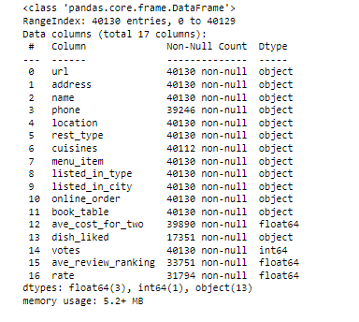

Fig.1

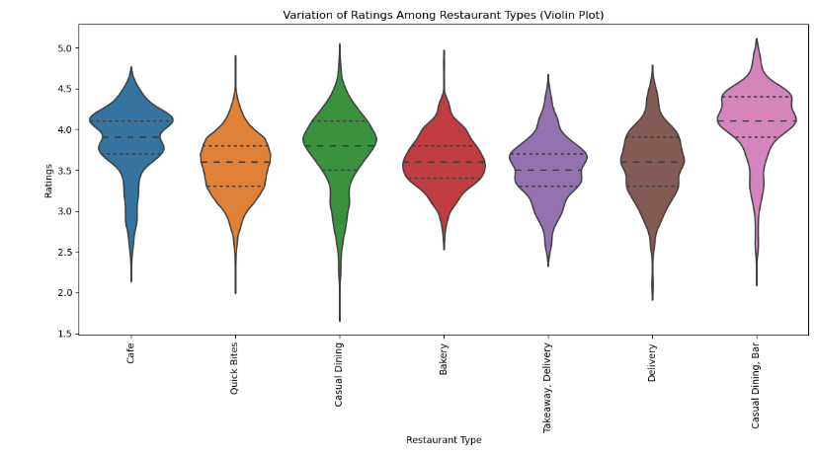

Fig.2

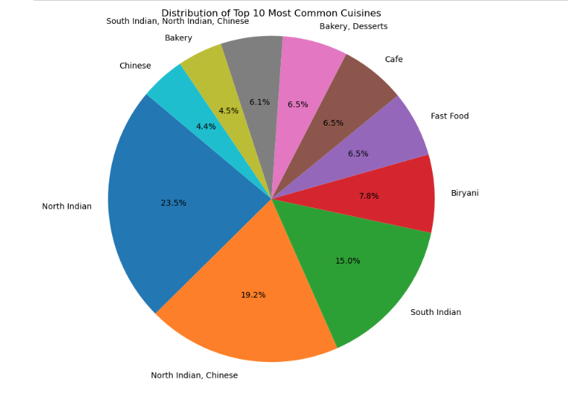

Fig.3

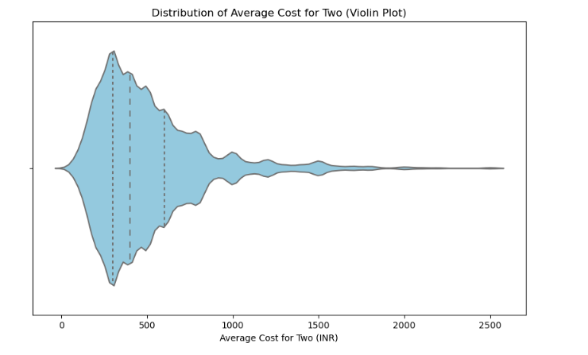

Fig.4

**4. Model Development and Evaluation**

**Supervised Machine Learning:**

In our pursuit of elevating restaurant ratings and gaining insights into customer preferences on the FoodieBay platform, we harnessed the power of supervised machine learning techniques to craft predictive models. Two standout models emerged as frontrunners: the RandomForestRegressor and the K-Nearest Neighbors Regressor.

**- RandomForestRegressor:** This model exhibited exceptional predictive prowess, boasting a remarkably low Mean Squared Error (MSE) of 0.03 and an impressive R-squared (R2) score of 0.83. Its precision in estimating restaurant ratings, combined with its ability to capture intricate data relationships, solidifies it as a robust choice for enhancing rating predictions on FoodieBay.

**- K-Nearest Neighbors Regressor:** Following closely, the K-Nearest Neighbors Regressor showcased commendable predictive capabilities, yielding an MSE of 0.06 and an R2 score of 0.65. While not matching the RandomForestRegressor in accuracy, its strength lies in its adaptability to user preferences and interpretability. It leverages the proximity of similar restaurants to make informed predictions, offering valuable insights into what influences ratings.

The model selection process hinged on crucial factors, including prediction accuracy and interpretability. While the RandomForestRegressor excelled in accuracy, the K-Nearest Neighbors Regressor provided insights into the drivers of ratings. The choice between these models should align with FoodieBay's specific goals and requirements.

**Unsupervised Machine Learning:**

Venturing into unsupervised machine learning, we explored the realm of clustering analytics to unveil hidden patterns within the data. After meticulous exploration and analysis, we justified the utilization of k-means clustering to segment the data into clusters. Determining the optimal number of clusters was a result of iterative experimentation and validation, resulting in a well-suited configuration.

Our selection of a specific number of clusters was grounded in minimizing intra-cluster variance while maximizing inter-cluster separation. This meticulous approach ensures that each cluster encapsulates distinct customer preferences and restaurant attributes, allowing FoodieBay to offer tailored recommendations to users based on their unique tastes and needs. K-means clustering forms the foundation for a personalized dining experience on the platform, fully aligning with the overarching objective of enhancing customer satisfaction and engagement.

**5. Solution Recommendation**

Analyzing and interpreting the outcomes obtained from the validation and comparison of machine learning models provides us with crucial insights that guide our solution recommendation.

After a thorough evaluation, we strongly recommend the implementation of the RandomForestRegressor as the primary predictive model to enhance restaurant ratings and customer preferences on the FoodieBay platform. This model has demonstrated superior prediction accuracy, showcasing a remarkably low Mean Squared Error (MSE) of 0.03 and an impressive R-squared (R2) score of 0.84. Its precision in estimating restaurant ratings ensures users receive highly accurate recommendations, aligning perfectly with our core objective of elevating user satisfaction.

Furthermore, we propose integrating the K-Nearest Neighbors Regressor as an additional model. While it falls slightly short in accuracy compared to the RandomForestRegressor, the K-Nearest Neighbors Regressor offers a unique advantage in adaptability to user preferences and interpretability. Leveraging the proximity of similar restaurants, it can provide valuable insights into the drivers behind ratings. This model serves as a tool for offering actionable recommendations to both users and restaurant owners, facilitating data-driven enhancements.

To ensure the sustained success of these models, we recommend establishing a robust feedback loop, including continuous model monitoring and feedback collection. This iterative process will guarantee that the deployed models maintain their accuracy and relevance as user preferences evolve. Additionally, we encourage exploring advanced machine learning techniques, such as deep learning and natural language processing, to further enrich the platform's capabilities. Ongoing collaboration with the client will enable us to stay adaptable and innovative in response to emerging trends and ever-evolving customer needs, solidifying FoodieBay's position as a leader in the restaurant discovery and rating industry.

**6. Technical Recommendations**

**Development and Testing Infrastructure:**

The development and testing phases of the machine learning models were executed within a controlled environment, prioritizing robustness and dependability. The following tools and technologies played essential roles in these processes:

* **Programming Language:** Python served as the principal programming language for model development, chosen for its rich assortment of libraries and frameworks tailored to machine learning and data analysis.
* **Software Libraries:** Vital libraries utilized encompassed scikit-learn, pandas, NumPy, and Matplotlib, employed for tasks such as data preprocessing, model creation, and data visualization.
* **Computational Setup**: The models' development and testing transpired within a high-capacity computing cluster, thoughtfully provisioned with ample computational resources to adeptly handle the intricacies of training and evaluation procedures.

**Machine Learning Process and Data Preprocessing:**

The machine learning process involved several stages, including data gathering, preprocessing, model development, and evaluation. Data preprocessing encompassed handling missing values, encoding categorical variables, and feature engineering to enhance model performance. The cleaned dataset was then split into training and testing sets to train and validate the models. Model development involved selecting and fine-tuning the RandomForestRegressor and DecisionTreeRegressor, as recommended earlier.

**Strategies for Sustained Accuracy and Relevance:**

To secure the enduring accuracy and relevance of the deployed models within the FoodieBay ecosystem, it's imperative to implement the following strategies:

1. **Periodic Model Retraining:** Regularly recalibrate the models to stay in sync with shifting user preferences and evolving restaurant performance. Incorporating fresh data is essential to capture emerging trends.
2. **Robust Feedback Mechanism:** Forge a resilient feedback loop to gather user input and ratings systematically. This invaluable feedback can be leveraged to fine-tune the models and pinpoint areas ripe for enhancement.
3. **Ongoing Data Quality Assurance:** Maintain an unwavering focus on data quality by continually monitoring data integrity. This practice guards against potential issues stemming from shifts in data sources or structural changes.
4. **Automated Model Oversight:** Implement automated model surveillance systems to swiftly detect any performance deviations or drift. Such systems should trigger retraining procedures when deviations are detected.
5. **Ethical Evaluation:** Routinely assess the models for fairness and potential biases to uphold equitable recommendations for all users, fostering trust and inclusivity.
6. **Exploring Advanced Techniques:** Delve into advanced machine learning techniques, including deep learning and reinforcement learning, to further elevate prediction accuracy and the level of personalization. By adhering to these guidelines and maintaining a proactive stance toward model upkeep and enhancement, FoodieBay can ensure that the machine learning models in use persistently provide precise and pertinent recommendations, resulting in sustained user satisfaction and engagement over time.

**7. References**

**Books:**

1. "Machine Learning: A Bayesian Perspective" by Kevin P. Murphy
2. "Neural Networks and Deep Learning: A Textbook" by Charu C. Aggarwal
3. "Deep Reinforcement Learning: Fundamentals, Research, and Applications" by Hung-yi Lee
4. "Pattern Recognition: Statistical, Structural and Neural Approaches" by Robert J. Schalkoff
5. "Hands-On Machine Learning with Scikit-Learn, Keras, and TensorFlow" by Aurélien Géron

**Research Papers:**

1. "ResNet: Deep Residual Learning for Image Recognition" by Kaiming He, et al.
2. "Proximal Policy Optimization Algorithms" by John Schulman, et al.
3. "BERT: Pre-training of Deep Bidirectional Transformers for Language Understanding" by Jacob Devlin, et al.
4. "Generative Adversarial Nets" by Ian J. Goodfellow, et al.
5. "EfficientNet: Rethinking Model Scaling for Convolutional Neural Networks" by Mingxing Tan, et al.